With financial support from
the Russian Federation

Russian Federation-UNDP Trust Fund for Development (TFD)
Project title: | Digital skills and opportunities for youth employment towards digital economy in the Kyrgyz Republic
Project ID: | 00114503
Implementing partner: | Ministry of Education of the Kyrgyz Republic
Project budget: | Total: 1,000,000 USD  TFD: 1,000,000 USD
Project start and end date: | February 2019 – June 2021  Extension #1 – until December 2021  Extension #2 – until 31 May 2022
Period covered in this report: | January 2022 – May 2022
Date of the last Project Board meeting: | 18 April 2022
SDGs supported by the project: | Youth and 2030 Agenda: The importance of Youth is recognized in the 2030 Agenda for Sustainable Development and SDGs which set out to ‘substantially increase the number of youth and adults who have relevant skills, including technical and vocational skills, for employment, decent jobs and entrepreneurship’ by 2030 (target 4.4). Over a third of the global 169 SDG targets highlight the role of young people and the importance of their empowerment, participation, and well-being. 20 targets across six SDGs (2, 4, 5, 8, 10, 13, 17) are strongly focused on youth: Zero Hunger, Quality Education, Gender Equality, Decent Work and Economic Growth, Reduced Inequalities, and Climate Action.

During the project extension, reporting period, the project achieved the following main results:
- The official launch of the ITHubOsh in Osh city
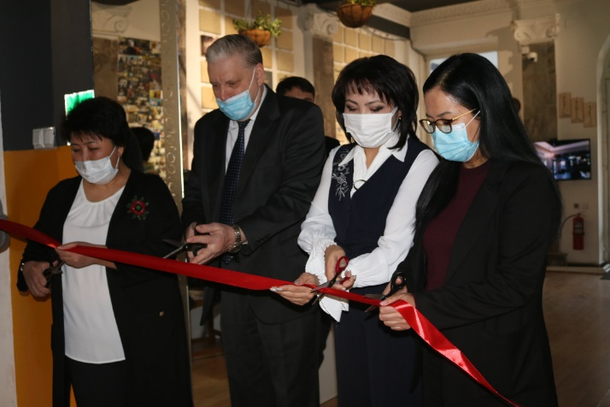
On 25 January 2022 the United National Development Programme in the Kyrgyz Republic inaugurated the first IT-Hub in Osh city with support from the Russian Federation. The purpose of the IT hub is to provide a platform for training young people in creative digital professions, including IT fields, which meet the growing high demands of the technological labour market. Representatives of the Ministry of Digitalization, Ministry of Education and Science, representatives of the Russian delegation, Mayor of Osh, representatives of the Osh University of Technology and journalists attended the ceremony.
IT-Hub Osh is the first new-format digital education hub in the south of the country and will aim to strengthen the education system and apply new educational standards in the field of digital skills to better prepare young people for the fast-changing world and contribute to the creative economy. The activities of the hub will support the nationwide digital transformation programme "Sanarip Kyrgyzstan" launched by the government in 2017 to create a transparent and knowledge-based economy, improve living standards and the business environment.
UNDP partnered with WelcomeKG Public Foundation expected IT-hub to become an active venue for online webinars, business trainings and hybrid events for all interested beneficiaries in the areas of creative economy, including digital skills, competencies and entrepreneurship.
IT hub in Osh: a virtual video tour https://youtu.be/MNhqsFXogYQ
By end of May 2022 20 companies operate in ITHubOsh: Phoenix MA, Accelerate Prosperity, Kyrgyz Real Estate, DAI Global PEAK, Azattyk, HR company, IT academy, Logistics Company, VS Tech, Globus Consulting, Lawyer services, Logistics company “ Tursunbaeva”, Ingosstrakh, SaferWorld, WCL Laboratory, Glovo KG, Kalpak English Academy, Real estate agency, Befree, Chess Academy.
The age group of innovators (residents) is from 18 to 50 years old. Among innovators are 53 women and 51 men including WCL residents.
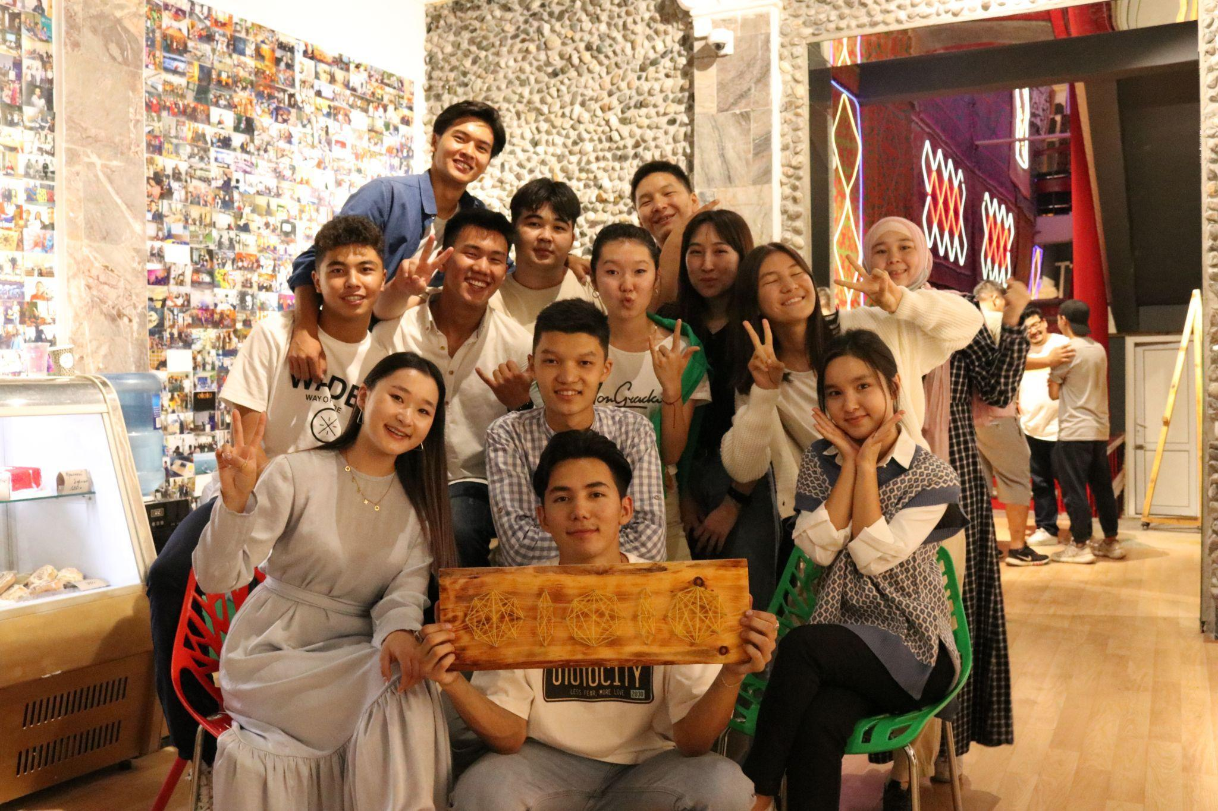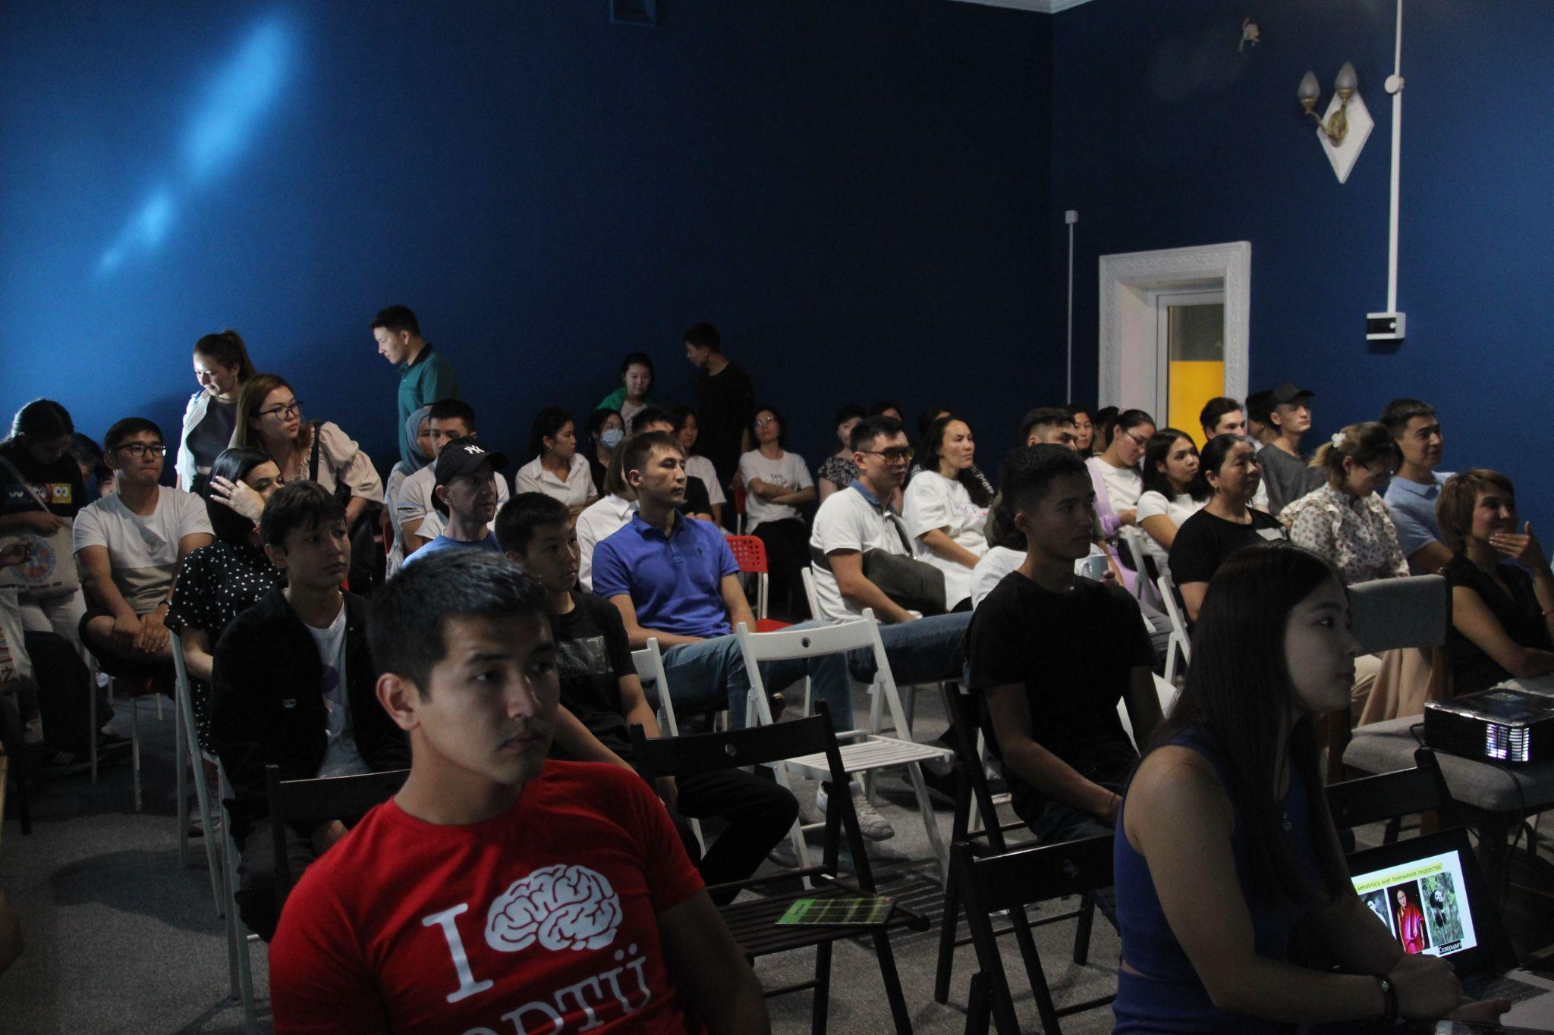

- Finalization the Final Evaluation of the project

The main purpose of the Final Evaluation was to assess the programmatic progress, performance of the project
interventions from the point of view of relevance, effectiveness, impact, organizational efficiency, sustainability as
well as analysis of lessons learnt highlighting areas where the project performed less effectively than anticipated. The findings of the evaluation will contribute to effective programming, refining the approaches, organizational learning and accountability.
The reason for the delay of the Final Evaluation connected with the pending approval of the Final Evaluation Report and scheduling of the wrap-up meeting with the Senior Management due to the end of the year hectic period and holiday season.
The evaluation found that the project was highly relevant as its design was embedded in a solid understanding of the of the challenges related to digital skill development (despite the fact that there is still no rigorous assessment of the digital literacy of the whole population and in particular of the youth in the country). The project presented a solid rational for investing in youth (vulnerable groups), for linking the education and digitization, and showing the nexus between nexus digitalization and employment. As digitalization is becoming a very high priority for Kyrgyzstan as well, the evaluation found that the development of this project is very needed and timely for the country.
The project resources were managed efficiently, and the project was able to smoothly transition all activities online when the pandemic struck the country. However, the project faced several challenges and delays for implementing activity 2.1 (Strengthening the IThub in Osh) because of problems outside its control (political turnover and instability) and within its control (procurement problems to validate a private sector company).
- Finalization of developing video lessons on new subjects for the Kyrgyz State Technical University and Osh Technological University
The aim of the activity was to strengthen the educational potential of a new generation of university teachers, namely the Kyrgyz State Technical University (KSTU) and Osh Technological University (OshTU) and to raise awareness of new teaching methods, including the development and creation of prototypes of new teaching materials for young people, including girls and youth with special needs, as well as the creation of an environment in which university teachers will have the opportunity for self-education, professional communication, exchange of experience, active participation in the discussion of ways to solve the problems of education in the field of informatics and ICT.
The reason for the delay in deliverables was a need to develop in-depth scenarios on subjects, which was new for the Universities and it required additional time for its official approval from project partners based in educational institutions.
As a result, video materials for students of universities of formal higher education were completed in the following 6 disciplines:
- data science;
- fundamentals of artificial intelligence;
- software design and security;
- cybersecurity technologies;
- neural networks and deep learning;
- machine learning.

In total 192 videos tutorials on 6 subjects, 96 of them in Russian and 96 in Kyrgyz, were developed with the duration at least 20 minutes each.
Photos from the filming location:
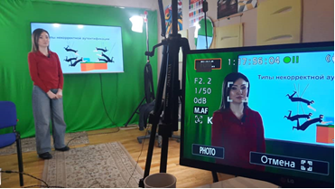
List of videos tutorials in Russian and Kyrgyz languages:
№ | Основы искусственного интеллекта
1 | Введение в искусственный интеллект | https://drive.google.com/file/d/1Ii6kFv1Umm7eneSk3V7kKBRWtunX9vKt/view?usp=sharing
2 | История и развитие ИИ. | https://drive.google.com/file/d/1eqyuusR_b27Q9rc8DgNZjfUuJLJ-3R3J/view?usp=sharing
3 | Модели представления знаний. | https://drive.google.com/file/d/1Xw1-421018hhExxcl0Ss28peY1UudbMP/view?usp=sharing
4 | Нечеткая логика. | https://drive.google.com/file/d/1534bkYD52k7uSjOUmPSLuaGEv5fBqphF/view?usp=sharing
5 | Экспертные системы. | https://drive.google.com/file/d/1WtwuoYOFZtURbFGtnZ7uX2IWAn3ZWrsm/view?usp=sharing
6 | Восприятие и интеллект. Распознавание объекта. | https://drive.google.com/file/d/1YGy6_fHCd7K6Fw97srTz5Sf-L2sSLEGd/view?usp=sharing
7 | Машинное обучение. | https://drive.google.com/file/d/1vfXiBsPqtQDEZF3Y7KYpZaRZEg-0vx0A/view?usp=sharing
8 | Глубокое обучение и нейронные сети. | https://drive.google.com/file/d/1ZaZj5N6p1Y7t-L8mjtluxaKCAOLj-9hk/view?usp=sharing
9 | Нейросетевые технологии. | https://drive.google.com/file/d/1QtqKDf2yrd4VRrva34CodZRvp9XvnadU/view?usp=sharing
10 | Алгоритмы в AI. | https://drive.google.com/file/d/1KQtpulhKP1GzUk8DtTH442cyvO9PIwLR/view?usp=sharing
11 | Обработка естественного языка (NLP). | https://drive.google.com/file/d/13WsocARa0OtuLtMfYdFTA40TV4RT31kP/view?usp=sharing
12 | Модель GPT 3. Проект Codex. | https://drive.google.com/file/d/1lPVvzoBzLJjm-qAuybqmmfOQ2RHha6oQ/view?usp=sharing
13 | Беспилотный автомобиль - ИИ и рабочие места. | https://drive.google.com/file/d/1w5TngKYlCNi1kGQCQMVyM1VjzFR-EIG-/view?usp=sharing
14 | Структура интеллектуальной робототехнической системы. | https://drive.google.com/file/d/1j2M3xFhB1DL5neqz_CcQCmKifznecjou/view?usp=sharing
15 | Аппаратное обеспечение в ИИ. | https://drive.google.com/file/d/1ANUWsmZBWrA3jlp2yvWSTGVZyFBhrAmB/view?usp=sharing
16 | Заключение. | https://disk.yandex.ru/i/IUS_Csi4bLUn3Q
№ | Жасалма интеллекттин негиздери
1 | Жасалма интеллекттин түшүнүктөрү. | https://drive.google.com/file/d/1zoGTJFUe8bJiKXX-nQAQddELxxevNpCC/view?usp=sharing
2 | ЖИ тарыхы жана өнүгүшү. | https://drive.google.com/file/d/1rwkbmrnJfHYF9P57mqUXqRXp5bBoHQwl/view?usp=sharing
3 | Билимди чагылдыруу моделдери. | https://drive.google.com/file/d/1DVBtla1HHM75HQKSKqq-ZUp-cuxasroz/view?usp=sharing
4 | Бүдөмүк логика. | https://drive.google.com/file/d/1R_-YQrgkicad_GRs2gh7UM-uX1YH49WI/view?usp=sharing
5 | Эксперттик системалар. | https://drive.google.com/file/d/1FtmX4xZ8_yaxQsUVSMSQ-_yKVb5eUTTH/view?usp=sharing
6 | Кабылдоо жана интеллект. Объекттерди аныктоо. | https://drive.google.com/file/d/1YWzy9J_zfgeS03IOLSYDpzFQbAP6lmqx/view?usp=sharing
7 | Машинанын үйрөнүүсү. | https://drive.google.com/file/d/1Z3_UQBKFguZTX_t-dwiaLNXa7rd2GSg4/view?usp=sharing
8 | Тереңдетилген үйрөнүү жана нейрондук тармактар. | https://drive.google.com/file/d/1hbq1ywGKAIl6ynQyaQown0qBbyLswaol/view?usp=sharing
9 | Нейрондук тармак технологиялары. | https://drive.google.com/file/d/1evZC_srHlz3BNOAi_KFjJ6dqNn0UAoV1/view?usp=sharing
10 | ЖИ алгоритмдери. | https://drive.google.com/file/d/1uPJlbk4ubUBMJAm1kgOqRlEGMbrtV1mw/view?usp=sharing
11 | Табигый тилди иштетүү (NLP). | https://drive.google.com/file/d/1PKvgqbe7VvxiRkBnBO3FsgOBg6nTSF01/view?usp=sharing
12 | GPT 3 модели. Codex долбоору. | https://drive.google.com/file/d/1FHjYpnjUiRcyiOutanWpsVCDBJlHZbDQ/view?usp=sharing
13 | Айдоочусуз унаалар. ЖИ жана жумуш орундары. | https://drive.google.com/file/d/1k2mmaape3UdxDOj6Ztx8nzAUaW_HY-k4/view?usp=sharing
14 | Акылдуу робот системасынын түзүмү. | https://drive.google.com/file/d/1KTYNNwQ2jk0yqWJLItP3C85uPZ7WcEgP/view?usp=sharing
15 | ЖИ жабдыктары. | https://drive.google.com/file/d/1F0p8Z54KMU0ADdgOAQelt06RzmAuizUZ/view?usp=sharing
16 | Жыйынтык. | https://drive.google.com/file/d/19PSrOeSIKGr6NIGv_toWsUHSYATp7ngm/view?usp=sharing
№ | Нейронные сети и глубокое обучение
1 | Введение в Нейронные сети и Глубокое обучение | https://drive.google.com/file/d/1lyWjHhncVgJMl8OEnDFc-gBAT-lXYwIT/view?usp=sharing
2 | Интуиция глубокого обучения. | https://drive.google.com/file/d/1gO3ByC6ptNE_jH5XTzqXbpobHQt6ppEW/view?usp=sharing
3 | Основы нейронной сети. | https://disk.yandex.ru/i/sUg99yzdSiucyA
4 | Ключевые концепции глубоких НС. | https://disk.yandex.ru/d/zkGrFmfa1VNeGg
5 | Глубокие нейронные сети. | https://drive.google.com/file/d/1OkCOs8Lp3Bd6HH-ic4bFeZzpYvzZueZK/view?usp=sharing
6 | Неглубокая нейронная сеть. | https://disk.yandex.ru/i/xP4GjLY4QJ0s_g
7 | Практические аспекты глубокого обучения. | https://drive.google.com/file/d/1hvbAygwBC2cSFnsHHOHnr5KfPpdQqdVk/view?usp=sharing
8 | Алгоритмы оптимизации.
9 | ИИ и здравоохранение. | https://drive.google.com/file/d/1TnnhPQDdXGgbpQiWYNEb8TWcPpQU9HdX/view?usp=sharing
10 | Стратегия машинного обучения (1). | https://disk.yandex.ru/i/wMjdI0Of-mdAtg
11 | Стратегия машинного обучения (2). | https://disk.yandex.ru/d/E011rvr4dGUyMQ
12 | Сверточная нейронная сеть. | https://drive.google.com/file/d/13X_tOotJ57WYBYkfZsU5z06UsSyx3gKS/view?usp=sharing
13 | Рекуррентные нейронные сети. | https://drive.google.com/file/d/17b_jaYVr1GlSAxpHg7S0NpxDYf8YBscd/view?usp=sharing
14 | Модели Sequence-to-Sequence. | https://drive.google.com/file/d/17g_N21r1FxbTog1D2UuzGvBswiVn0Xd9/view?usp=sharing
15 | Глубокое обучение с подкреплением. | https://drive.google.com/file/d/1ZpfAinmqFEoS-4ddG7Rlu-NCU0yCbuJz/view?usp=sharing
16 | Заключение. | https://disk.yandex.ru/i/MMlc11mqa1W7Pw
№ | Нейрондук тармактар жана тереңдетилген үйрөнүү
1 | Нейрондук тармактар жана тереңдетилген үйрөнүүнүн негиздери | https://drive.google.com/file/d/1E8JU8SGv1X6TFMtrOBQMQQgR6rh6hABK/view?usp=sharing
2 | Тереңдетилген үйрөнүүнүн интуициясы. | https://drive.google.com/file/d/1S5b0cMnsEB4V0dxm76Nq2a59Wewd0QKU/view?usp=sharing
3 | Нейрон тармагынын негиздери. | https://drive.google.com/file/d/1ttSHDdzhrnDmFHHpfM-4EzC_NqFZAGkv/view?usp=sharing
4 | Тереңдетилген НТ боюнча негизги түшүнүктөр. | https://drive.google.com/file/d/1nM7JhUULczwNCMXaAFyrOpEP6Se2e4aX/view?usp=sharing
5 | Тереңдетилген нейрон тармактары. | https://drive.google.com/file/d/1qWVxZJlpbi0cDagZbBNh8FM_VrSs_ahW/view?usp=sharing
6 | Тайкы нейрон тармагы.
7 | Тереңдетилген үйрөнүүнүн практикалык жактары.
8 | Оптималдаштыруу алгоритмдери.
9 | ЖИ жана саламаттыкты сактоо тармагы.
10 | МҮ стратегиясы (1).
11 | МҮ стратегиясы (2).
12 | Конволюциялык нейрон тармагы.
13 | Рекурренттик нейрон тармагы.
14 | Sequence-to-Sequence моделдери.
15 | Терең бышыкталган үйрөнүү.
16 | Жыйынтык.
№ | Машинное обучение
1 | Что такое машинное обучение? | https://drive.google.com/file/d/13SCZ1sOmVjGouK-F6B6dQ1nfplewHW8W/view?usp=sharing
2 | Контролируемое обучение. | https://drive.google.com/file/d/1wxXfOEtw8NicYZgjlvSIZNn4cPwQE6W9/view?usp=sharing
3 | Неконтролируемое обучение. | https://drive.google.com/file/d/18xkKN-7ALlEzGyTBcENzPmKvOop6eSl3/view?usp=sharing
4 | Обучение с подкреплением. | https://drive.google.com/file/d/174acw9q8x_lhsmY9UeERjhCy-D0dSAWy/view?usp=sharing
5 | Математические основы. | https://drive.google.com/file/d/1qj7fdT2gO53KDQww25IRZwbVt_0V_EyX/view?usp=sharing
6 | Введение в теорию вероятности. | https://drive.google.com/file/d/12SFrXhfBsdEIdSlzzP-txTBJD26Z-T2X/view?usp=sharing
7 | Обзор линейной алгебры. | https://drive.google.com/file/d/1lIFViiqXB1zebGcGiCyWM6IH69BUcpdJ/view?usp=sharing
8 | Линейная регрессия с одной переменной. | https://drive.google.com/file/d/1HMdQIUqPMAvqZ8mpnv3VWGFMgGw0sCiM/view?usp=sharing
9 | Линейная регрессия с несколькими переменными.
10 | Логистическая регрессия.
11 | Регуляризация.
12 | Octave / Matlab
13 | Нейронные сети. | https://drive.google.com/file/d/17OkgZIKi7iX_KFWLJaRNcGV2w8JshFwG/view?usp=sharing
14 | Проектирование системы машинного обучения.
15 | Опорные векторные машины.
16 | Заключение.
№ | Машинанын үйрөнүүсү
1 | Машинанын үйрөнүүсү деген эмне? | https://drive.google.com/file/d/1HI-iCgSJ0StWBbijqzYDY51fr6fSBvKZ/view?usp=sharing
2 | Көзөмөлдөнгөн үйрөнүү. | https://drive.google.com/file/d/1HhH3-E6JDfVAKQM2-36mpZFMOilFq8fs/view?usp=sharing
3 | Көзөмөлсүз үйрөнүү. | https://drive.google.com/file/d/1n6t5T1ywAIRjo6nG5NQ0l3ScFQXVu5GW/view?usp=sharing
4 | Бышыкталган үйрөнүү. | https://drive.google.com/file/d/1yzMmdSiZieJKqbTDzwCWVrCbeB7ptCjW/view?usp=sharing
5 | Математикалык негиз. | https://drive.google.com/file/d/1ID-AlWP5pBBWox0hBhnAWrDpcLi8xJRB/view?usp=sharing
6 | Ыктымалдуулук теориясынын негиздери. | https://drive.google.com/file/d/1FcFFc3iCAYgfrYQk2jq0pGSsqgheZhiV/view?usp=sharing
7 | Сызыктуу алгебрага жөнүндө жалпы түшүнүктөр. | https://drive.google.com/file/d/1bYRTivmsecZ4Xxix8tGUb3CeaCAUPJ3W/view?usp=sharing
8 | Бир өзгөрмөлүү сызыктуу регрессия. | https://drive.google.com/file/d/1qDhoYaQWMk5PqKnS9DjKVnKDD220HN3Z/view?usp=sharing
9 | Бир нече өзгөрмөлүү сызыктуу регрессия. | https://drive.google.com/file/d/1rq3GmOXFvhx85e5ETttqxN6CVsjuTFLs/view?usp=sharing
10 | Логистикалык регрессия. | https://drive.google.com/file/d/1WqRFV5kAAw2GqiN0F66sel9vfGxT-E8i/view?usp=sharing
11 | Регуляризация. | https://drive.google.com/file/d/1d3Q-FK4rMUnVsCmzCPswzHeyXv_npIlK/view?usp=sharing
12 | Octave / Matlab | https://drive.google.com/file/d/1z6kuG_yPjFl76j9sRVh5icdm1JsKXJyw/view?usp=sharing
13 | Нейрон тармактары. | https://drive.google.com/file/d/1ljadHk7o1jB5Aer2JWzw3OlOxIg28aSJ/view?usp=sharing
14 | Машинанын үйрөнүү системасынын дизайны. | https://drive.google.com/file/d/1LhO7fschLp0hvlMjrpkVtaMviUiTv1bY/view?usp=sharing
15 | Жөлөк вектордук машиналар. | https://drive.google.com/file/d/1BXQUZx34hiaAPTquwC-VV-QplOjPj08J/view?usp=sharing
16 | Жыйынтык. | https://drive.google.com/file/d/1Pr7g1TcSET3eKCkkSfEr0TFPhr4gHTsA/view?usp=sharing
№ | Проектирование и обеспечение безопасности ПО
1 | Введение в проектирование ПО и безопасность. | https://drive.google.com/file/d/1U2h62CwMQ6ubppeEYL28tk8r13Fk9btl/view?usp=sharing
2 | Основы разработки ПО. | https://drive.google.com/file/d/1sG8caksygrLPEdGfRv6bomVHvCjMFY8m/view?usp=sharing
3 | Типы ПО. | https://drive.google.com/file/d/1zqF0Fd9N4hamV0BHLDh-LG9weo7ee-BM/view?usp=sharing
4 | ПО с открытым кодом. | https://drive.google.com/file/d/1CxE30TNSXNI74s0HOpDjuER1Wwm4VQep/view?usp=sharing
5 | Архитектура программного обеспечения. | https://drive.google.com/file/d/1yaX-yQaof6WiR0y3iMcHJ22u-1IxPLuY/view?usp=sharing
7 | Веб-приложения. | https://drive.google.com/file/d/1YpxTYTUTE15YO6TidB2dTLnnA0oZX15H/view?usp=sharing
9 | Процесс разработки. | https://drive.google.com/file/d/1BpyzYB-mfXUGHR7-NW2ckFyWB4x8J1A-/view?usp=sharing
10 | Гибкая разработка. | https://drive.google.com/file/d/15rbL5q0qChc14h_IPqznfgynLFg2tHEZ/view?usp=sharing
11 | Документирование. | https://drive.google.com/file/d/1Fsd8dOu9fJQ7LR7VsuUV1sQzNBEqEBOb/view?usp=sharing
12 | Пользовательский интерфейс. | https://disk.yandex.ru/i/wxbjRqIjWyJeiA
13 | Основы безопасности ПО. | https://disk.yandex.ru/i/DtqoSkfDVNWe_g
14 | Авторизация, аутентификация и ведение журнала. | https://disk.yandex.ru/i/mjAd9qbMvlZ2cw
15 | Тестирование ПО. | https://disk.yandex.ru/i/UXBbwTvUv9wCkg
16 | Заключение. | https://disk.yandex.ru/i/3ZtjE7aWiD9vjA
№ | ПКну жана коопсуздугун долборлоо
1 | ПК дизайны жана коопсуздугуна киришүү. | https://drive.google.com/file/d/1rqlf-yW115BzefF08h10QaiDP2UmIrm7/view?usp=sharing
2 | ПК дизайнынын негиздери. | https://drive.google.com/file/d/1WUarD9_114t8LKOzmiG51z7Ehdz7T2sa/view?usp=sharing
3 | Программалык камсыздоонун түрлөрү. | https://drive.google.com/file/d/1TIYv62I8Iv7yKSMZ4ZUEMnhGREtXM2Bh/view?usp=sharing
4 | Коду ачык программалар. | https://drive.google.com/file/d/11Kg2fI-S1A2PTu-AwEXAILmuCQj_K6K3/view?usp=sharing
5 | Программалык камсыздоонун архитектурасы. | https://drive.google.com/file/d/1drTymbG22J0ncHFqJm2D6mH9RG0YIqoM/view?usp=sharing
6 | UML жана класстардын диаграммалары. | https://drive.google.com/file/d/1kGkCFrRhcKwV0nCtvrW64KDejywxfAHi/view?usp=sharing
7 | Веб колдонмолору. | https://drive.google.com/file/d/1y0Kn914T73xVwHQYb1jn42-swAz_O9Ar/view?usp=sharing
8 | Дизайн ишинин жүрүшү. | https://drive.google.com/file/d/1oKaio3K4IZOn6f_i51xmH4HY63SBOwHo/view?usp=sharing
9 | Иштеп чыгуунун жүрүшү. | https://drive.google.com/file/d/1rf6KaZDWgxenJjhlRvUO6u7InHPq_6Ed/view?usp=sharing
10 | Agile иштөө. | https://drive.google.com/file/d/1HS59MtENM1Py_wfbHG6g5OmvFrCQnzS-/view?usp=sharing
11 | Документтештирүү. | https://drive.google.com/file/d/1-Kd9RdUtyu4fFktI6zlFt-qEYtZF7gAZ/view?usp=sharing
12 | Колдонуучу интерфейси. | https://drive.google.com/file/d/1zD7YVE1vd8j2KPvlFDQkBSSV5XRum1Zj/view?usp=sharing
13 | Программалык камсыздоонун коопсуздук негиздери. | https://drive.google.com/file/d/1rYY0yGKP4qjrknORRkU-UuonUMmnkndt/view?usp=sharing
14 | Авторизация, аутентификация жана каттоону жүргүзүү. | https://drive.google.com/file/d/1RgZvxBvDCto32hijthI9-ZnUDSysjPyd/view?usp=sharing
15 | Программалык камсыздоону сыноо. | https://drive.google.com/file/d/1iCNBqgsyZnTLUKxtO52DyLUfPF-MchOf/view?usp=sharing
16 | Жыйынтык. | https://drive.google.com/file/d/1rmoxOvdiqQt-NONHFXFi9PABTniTyryV/view?usp=sharing
№ | Наука о данных
1 | Что такое наука о данных? | https://drive.google.com/file/d/1pInCjoDtibpvGuBNXPyfPjPiKkbJ5nfu/view?usp=sharing
2 | Типы данных. | https://drive.google.com/file/d/1WtwAUC6ZtIUV_q7njDuklMe04oUvesox/view?usp=sharing
3 | Визуализация данных. | https://drive.google.com/file/d/1npGBMRgwQEjOQ9efXNVaKrt1oOU2h-BD/view?usp=sharing
4 | Принципы проектирования визуализации данных. | https://drive.google.com/file/d/1UhhalXtfGABcKACF05Sp2aWVG2-jZU42/view?usp=sharing
5 | Использование D3.js для визуализации данных.
6 | Веб-приложения для визуализации дизайна. | https://drive.google.com/file/d/1x6dE18Vw2ej-xvCP4QbjxqkK747ExY_A/view?usp=sharing
7 | Примеры визуализации на тестовых данных. | https://drive.google.com/file/d/1heI29WWgsodNXJPv4Sz0NvVFvDMwl3hS/view?usp=sharing
8 | Статистика и обработка данных. | https://drive.google.com/file/d/1V2p6WfQkdDpEhTE4pC9GSdHae8eFo6Dk/view?usp=sharing
9 | Введение в вероятность и статистику. | https://drive.google.com/file/d/1N3AruSkP6dPQHJZNml7Z3CK9i-10n_dK/view?usp=sharing
10 | Кластеризация и классификация.
11 | Математическое моделирование в науке о данных.
12 | Вычислительные методы в науке о данных.
13 | Использование Python для науки о данных.
14 | Использование библиотеки R для науки о данных.
15 | Программное обеспечение науки о данных.
16 | Заключение
№ | Маалымат илими
1 | Маалымат илими деген эмне? | https://drive.google.com/file/d/1vKkGOcjSuyZook76B_rE1kdymk3p9tse/view?usp=sharing
2 | Маалыматтын түрлөрү. | https://drive.google.com/file/d/1I1o2UoqYzIKE4-KDX8y5GCe7R9CIZ6eA/view?usp=sharing
3 | Маалыматтарды визуализациялоо. | https://drive.google.com/file/d/1ECJknya58E1_S8ms6KGfOYNTIx10l7rZ/view?usp=sharing
4 | Маалыматтарды визуализациялоодо дизайн принциптери. | https://drive.google.com/file/d/1RnFDpT5pf1IsyNRHrHL63tIRL1pUJEjJ/view?usp=sharing
5 | Маалыматтарды визуализациялоо үчүн D3.jsти колдонуу. | https://drive.google.com/file/d/14Caf9tJUhlkuT_H57rlM9b_g3A01ubbq/view?usp=sharing
6 | Визуализациялоо үчүн веб колдонмолор. | https://drive.google.com/file/d/1TrT_ZKmY2pipX782NWRTcN1_pxiAQaYJ/view?usp=sharing
7 | Тест маалыматтар менен визуализациялоо өрнөктөрү. | https://drive.google.com/file/d/1ARtwJo_47WKQldnQueWV7uqcxJszxcOp/view?usp=sharing
8 | Статистика жана маалыматтарды иштетүү. | https://drive.google.com/file/d/1iFzvclrWr7Dp8HCjJq8YsaOi6SM4QC48/view?usp=sharing
9 | Ыктымалдуулук жана статистика негиздери. | https://drive.google.com/file/d/1-zOMOFy0HOpdXKEEVKVu8wTfmwUVM1NY/view?usp=sharing
10 | Кластерлөө жана классификация. | https://drive.google.com/file/d/1hpBEmhVb5d0lzvDiDC_6zAlf-JlDxDz_/view?usp=sharing
11 | Маалымат илиминде математикалык моделдөө. | https://drive.google.com/file/d/1Wew0lOhxJuH39g6WLybM3V3KQ2eQEbXY/view?usp=sharing
12 | Маалымат илими үчүн эсептөө ыкмалары. | https://drive.google.com/file/d/1VvMKTKfhCkoMOCsM1--Q9tmlRkf096gR/view?usp=sharing
13 | Маалымат илиминде Python колдонуу. | https://drive.google.com/file/d/1_R04bvgFexkB06r-Es4dpnMzyHVUq6dK/view?usp=sharing
14 | Маалымат илиминде R китепканасын колдонуу. | https://drive.google.com/file/d/1axhvVykHLAw0IFrLdC-X06M9Pg6gheqa/view?usp=sharing
15 | Маалымат илиминде программалык камсызоолор. | https://drive.google.com/file/d/1C9jogzaUS1Jchax_b6zPclHwQZyNIqGv/view?usp=sharing
16 | Жыйынтык | https://drive.google.com/file/d/1NO5A_BAXSsmv6Pq832z0MbZg-n3_CTlS/view?usp=sharing
№ | Технологии кибербезопасности
1 | Информационная безопасность. | https://drive.google.com/file/d/1_NishXE2UFOM0pc_2O_fwzqVV9ONlMSn/view?usp=sharing
2 | Основы Интернета и сети. | https://drive.google.com/file/d/1SfkX0HbnCIAxFueKnebIR6aKM16Wn5UV/view?usp=sharing
3 | Криптография. | https://drive.google.com/file/d/1Cg9J75JaceiuAkEgzAF1XmE7B10JVw7U/view?usp=sharing
4 | Поточные шифры. | https://disk.yandex.ru/i/vLzF5cbzpojb5A
5 | Блочные шифры. | https://drive.google.com/file/d/18R2P5KOE4Li2Enj_QSDxwxrQMOPgfZNu/view?usp=sharing
6 | Криптосистемы с открытым ключом.
7 | Взлом. | https://drive.google.com/file/d/13w1SR5CXqGmzQvlPDUkRHojqQ8RNQTnC/view?usp=sharing
10 | Социальная инженерия. | https://drive.google.com/file/d/12k9nUoZO3V6gklN-a2TSoqZoJzDwFMV6/view?usp=sharing
11 | Виды социальной инженерии. | https://drive.google.com/file/d/1Yt5cWHHTZJKn5nZ4_Mpwsl_trZqemPKr/view?usp=sharing
13 | Реагирование на инциденты. | https://drive.google.com/file/d/1RT-E2xfT_-IcHTeS7BS_teWTLU3kxwA-/view?usp=sharing
14 | Планы реагирования. | https://drive.google.com/file/d/153-gDvsg1UTQdeahTN92EikuXzMcT5x6/view?usp=sharing
15 | Политика информационной безопасности.
16 | Заключение.
№ | Киберкоопсуздук технологиялары
1 | Маалымат коопсуздугу. | https://drive.google.com/file/d/1OB24RfSjHxxeGk4XFsj2sBdT6uJKvnz5/view?usp=sharing
2 | Интернет жана компьютер тармактарынын негиздери. | https://drive.google.com/file/d/1ZIFvZIVnMJ0fCaEEIAa5eGsjmD5XpZB7/view?usp=sharing
3 | Криптография. | https://drive.google.com/file/d/1QxDLAw_uyPKwRx5u-pRX_fNz3XV_D0GX/view?usp=sharing
4 | Агым шифрлери. | https://drive.google.com/file/d/1zVlz7t_I_QEVKP_gzewuDSRIDvD1YQVw/view?usp=sharing
5 | Блок шифрлери. | https://drive.google.com/file/d/1bEQ8RHM83FlncI7zQ_gvX_lm3aEUYOsK/view?usp=sharing
6 | Ачык ачкыч крипто системалары. | https://drive.google.com/file/d/1VTzkIVLIyxlfc3eaqhkKWkiNTywRWpAq/view?usp=sharing
7 | Бузуу. | https://drive.google.com/file/d/1tLL_IehgLoYneVthSCOVtyco_N0Mo8VA/view?usp=sharing
8 | 10 эң кеңири тараган OWASP коркунуч моделдери. | https://drive.google.com/file/d/1tAA1fJEk1Xzyqwf0zD6mIJITZlrnhiOw/view?usp=sharing
9 | OWASP 10дон коргонуу ыкмалары. | https://disk.yandex.ru/i/1hj9cuf-IvB4ag
10 | Социалдык инженерия. | https://disk.yandex.ru/i/mngZUWTmS3cX4w
11 | Социалдык инженериянын түрлөрү. | https://drive.google.com/file/d/1BdtxQrhdHlRuHcMsfI--mC8QF08aOyLJ/view?usp=sharing
12 | Күнүмдүк жашоо маалыматтарын коргоо. | https://drive.google.com/file/d/1cZ7DpYiz1Yycsb13WBZ0Gfo69KNBj3Pu/view?usp=sharing
13 | Инциденттерге реакция. | https://drive.google.com/file/d/1ecyedAP9SLtgYIKZeNMkx2ld_9XfBMIf/view?usp=sharing
14 | Реакция пландары. | https://drive.google.com/file/d/1gYY1Wu2dDp32bai_gwDgiHDHt4SNUJFT/view?usp=sharing
15 | Маалымат коопсуздугу саясаты. | https://drive.google.com/file/d/1DcQ7TiBIW-hEgm8rQKkmRlsPUNv9JNVm/view?usp=sharing
16 | Жыйынтык. | https://drive.google.com/file/d/1m2-TeK9WB1x7dtS2J56xcltntWt7e8UW/view?usp=sharing

- Project delivery is 103% (GLGE to be issued to resolve the budget overspent/negative balance).

